http://lon400b:2001/HTTPAdmin
UAT details
Username WEBSERVADM
Password us2xbcpg

Option -39
Sub file fields
GCFMNP - FMMANAGER - Customer ID
gccmpP – CPCMPSN – company short name + GcCusp - MCLOCR - Location Code
GCFMNP – FMFUNDS - Customer ID

D1fndnm = gccmpP – CPCMPSN – company short name + GcCusp - MCLOCR - Location Code

Tables used
GCFMNP
GCFMNL1
GCCMPP
GCCUSP

Data structure
Fundmanager.CUSID
Fundmanager.NAMNE
Fundmanager.FMFUNDS
Fundmanager.NAMNE
Fundmanager.FMLDFLG

Wid ID - CORP\DARSHANI
204689 – Employee ID

How debug
- strsrvjob (614692/QUSER/QZRCSRVS)
- strdbg
If you are getting compilation errors due to WEB_ENV .H check the header file definitions at the very top of the program.

<soapenv:Envelope xmlns:soapenv="http://schemas.xmlsoap.org/soap/envelope/" xmlns:get="http://getfundmanager.wsbeans.iseries/">
<soapenv:Header/>
<soapenv:Body>
<get:gc253>
<arg0>
<EXIT1></EXIT1>
<FMGR>107717</FMGR>
<FUND>175706</FUND>
<MTHD></MTHD>
<__WINID>CORP\DARSHANI</__WINID>
<!--1 or more repetitions:-->
<FM_LIST>
<FUNDMANAGER>107717</FUNDMANAGER>
<FUNDMGRNAME></FUNDMGRNAME>
<FUNDS>175706</FUNDS>
<FUNDNAME></FUNDNAME>
<DELETED></DELETED>
</FM_LIST>
<ENVIRONMENT>DEV</ENVIRONMENT>
</arg0>
</get:gc253>
</soapenv:Body>
</soapenv:Envelope>

@sqlStmt = 'with cte_1 as ( ' +
' SELECT FMMANAGER,b.cpcmpsn,a.mclocr, ' +
' FMFUNDS,FMLDFLG ' +
' FROM gcfmnp,gccusp a,gccmpp b,gccmpp c WHERE ( ' +
' FMMANAGER= a.MCCNO and a.MCCMPTG= b.CPCMP and ' +
' char(FMMANAGER) = ' + %char(##fmgr) +
' and (b.cpcmpr = c.cpcmp))) ' +
' ,cte_2 as ( ' +
' SELECT cte_1.FMMANAGER,cte_1.cpcmpsn,cte_1.mclocr, ' +
' cte_1.FMFUNDS,b.cpcmpsn,a.mclocr,cte_1.FMLDFLG ' +
' FROM cte_1,gccusp a,gccmpp b,gccmpp c WHERE ( ' +
' cte_1.FMFUNDS= a.MCCNO and ' +
' char(cte_1.FMFUNDS) = ' + %char(fund) +
' and a.MCCMPTG= b.CPCMP and (b.cpcmpr = c.cpcmp))) ' +
' select * from cte_2 order by FMMANAGER ' ;

Steps to create a web service
- Give the name of the PGM option with the library as follows.
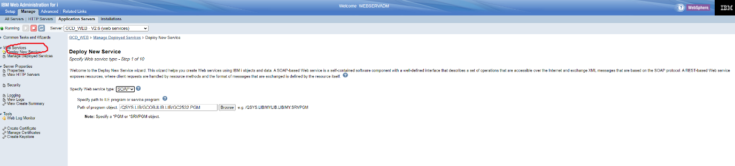

- Give a name to web service
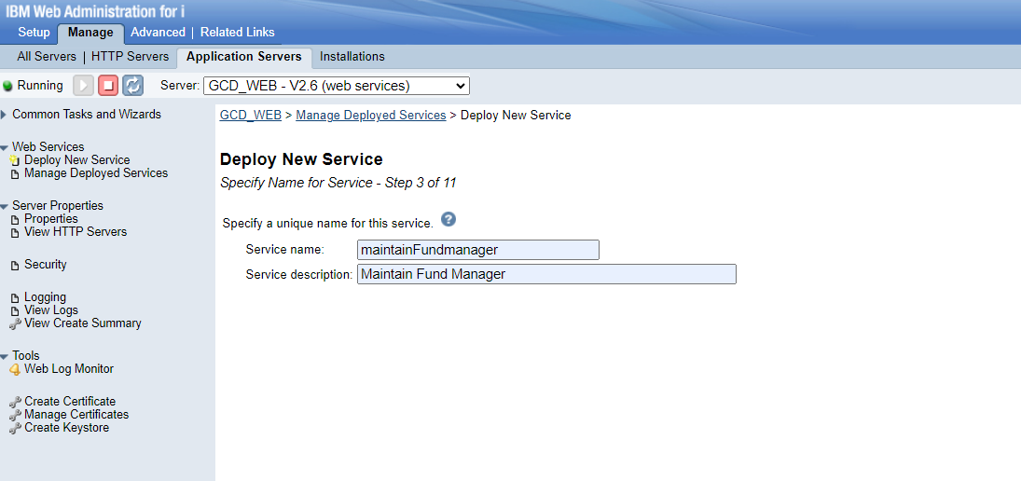
- Keep this screens unchanged.
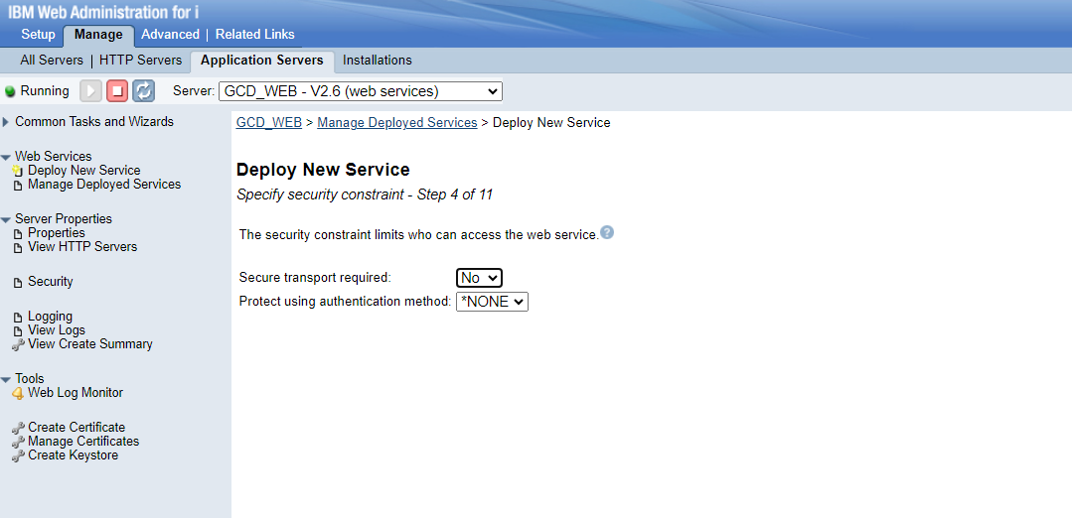
- Change the input output compatible to the parameters
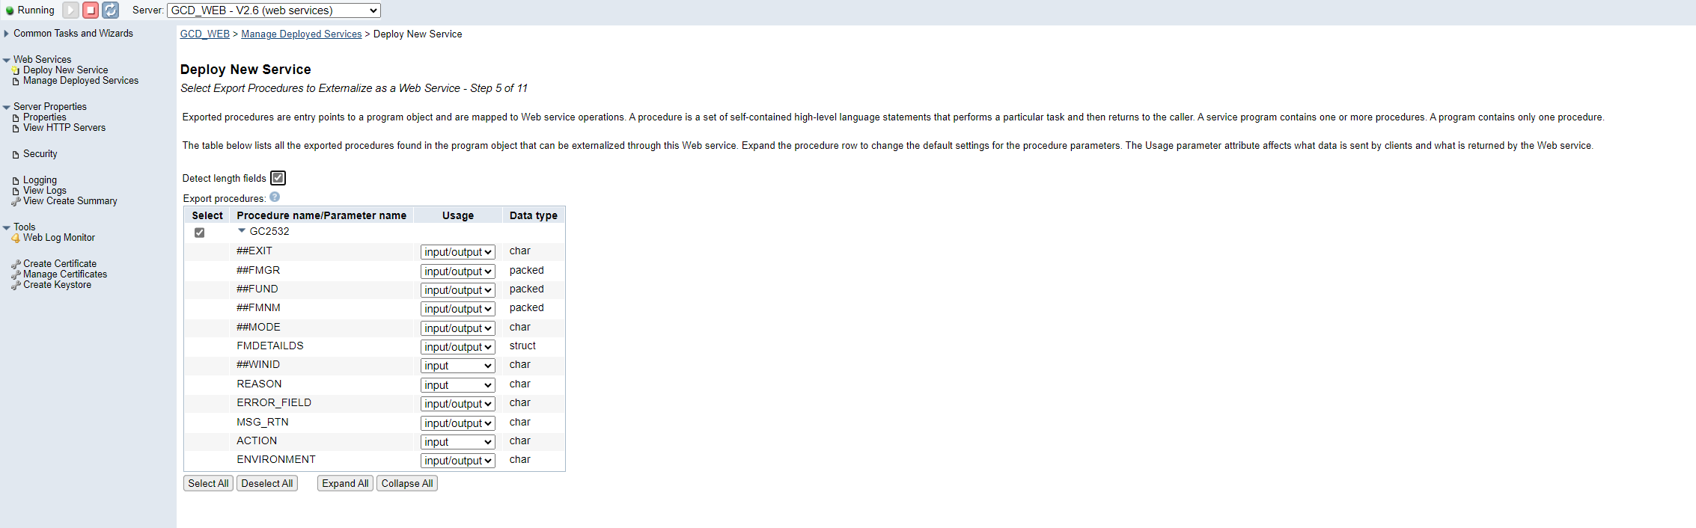
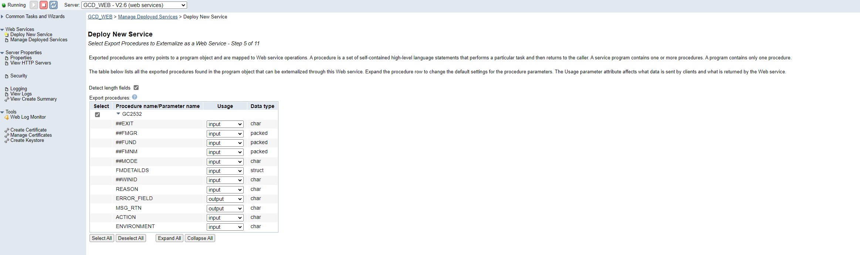
- Keep unchanged

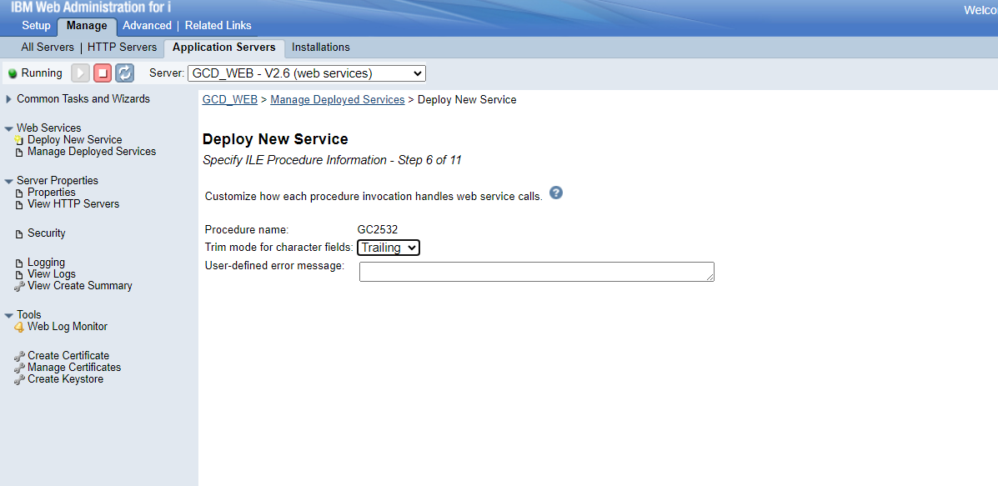

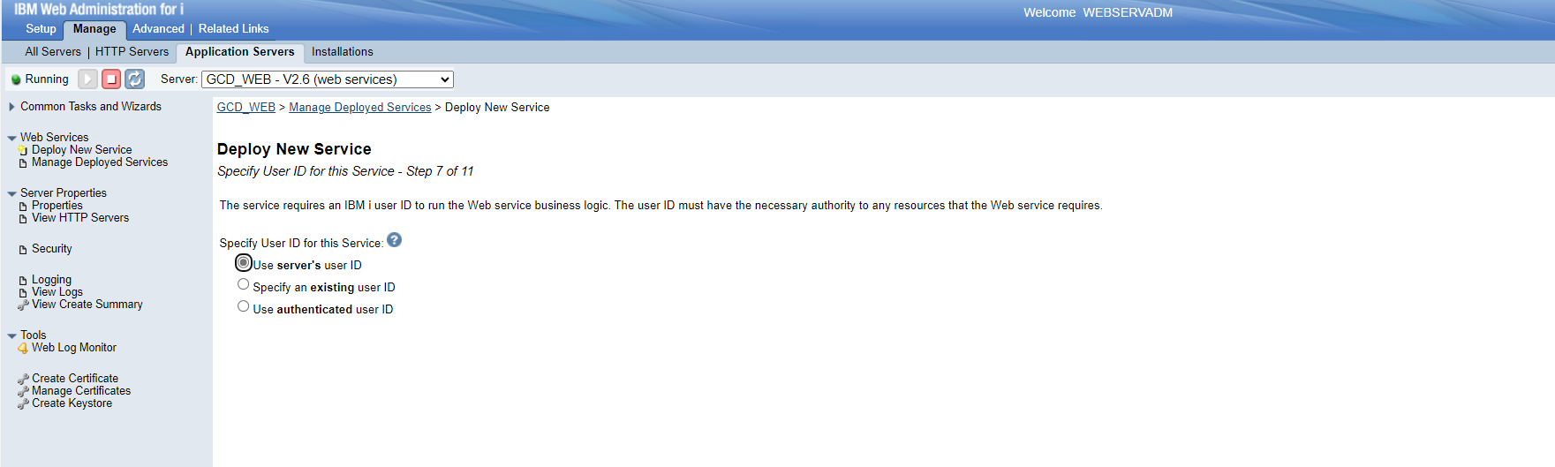

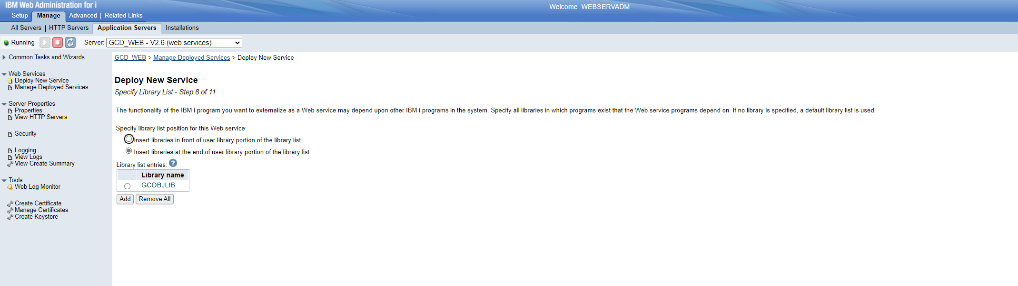
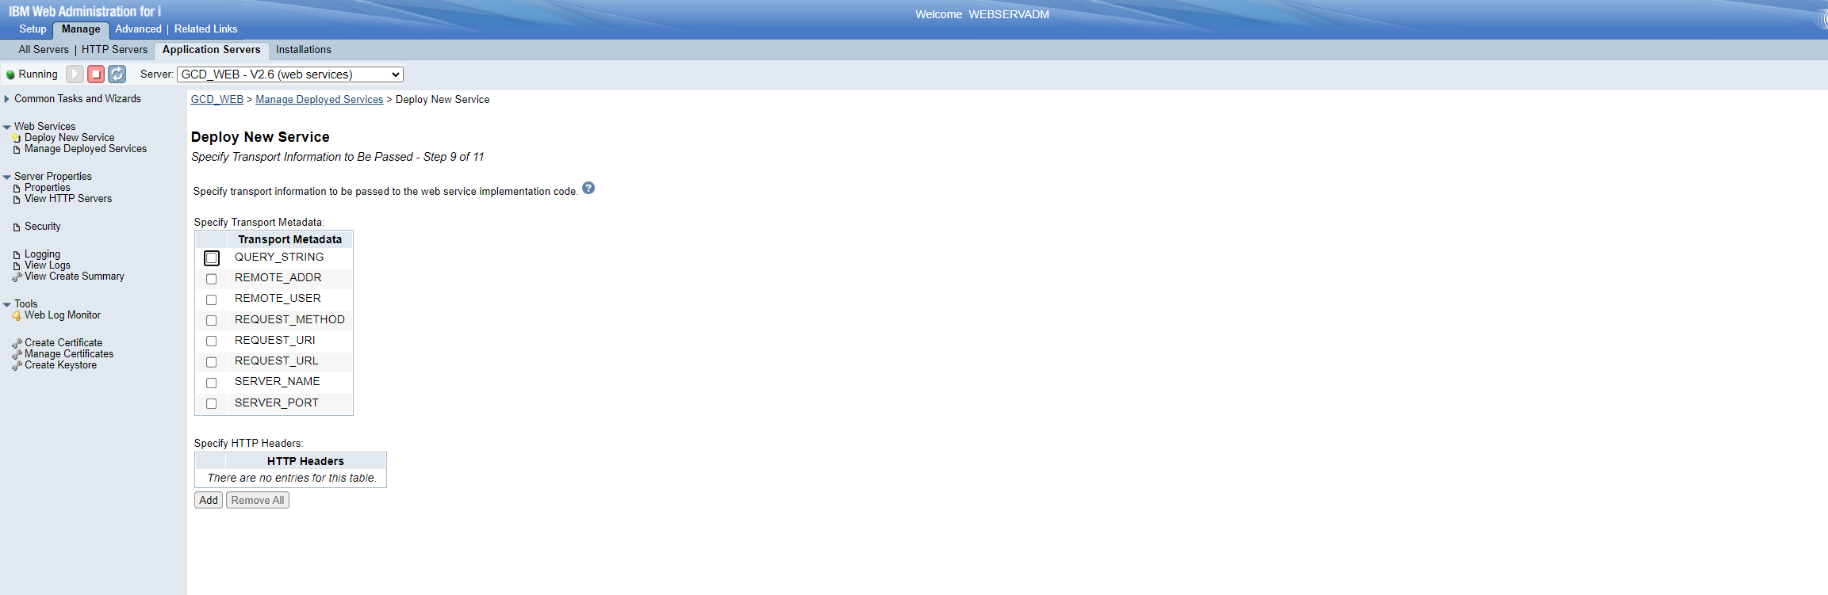
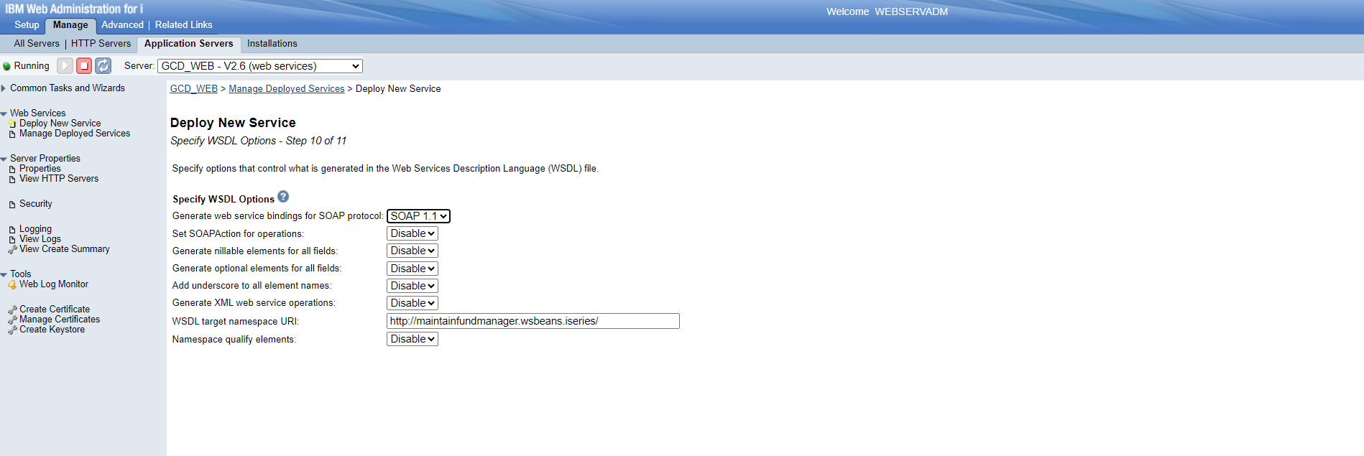
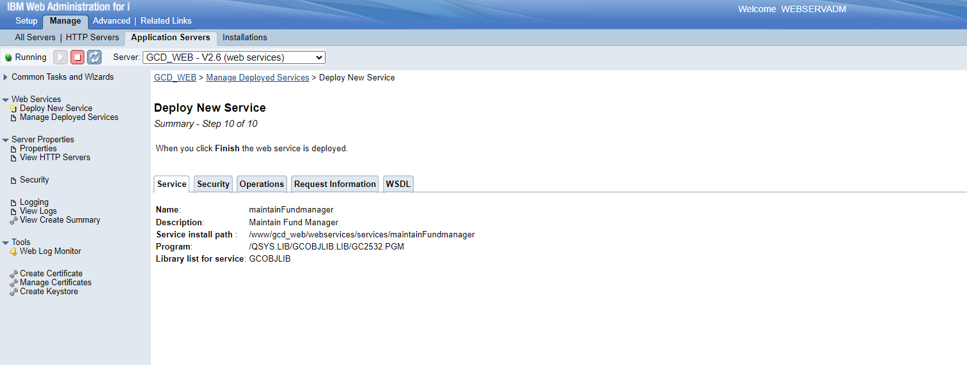
- It will take some time to install
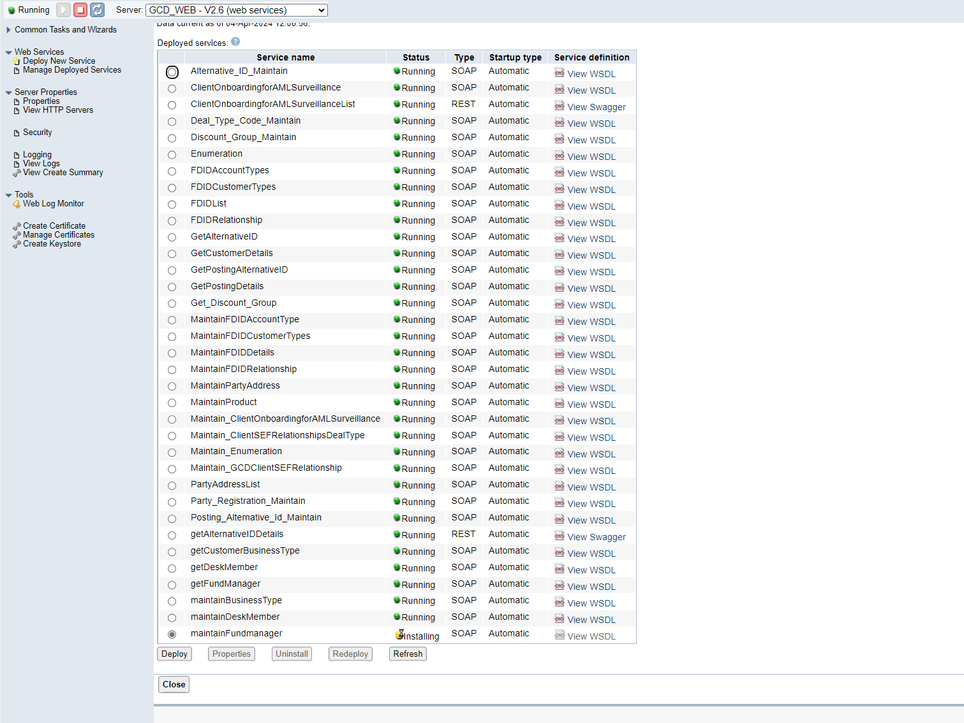
7.Once it has been installed you can see the running web service
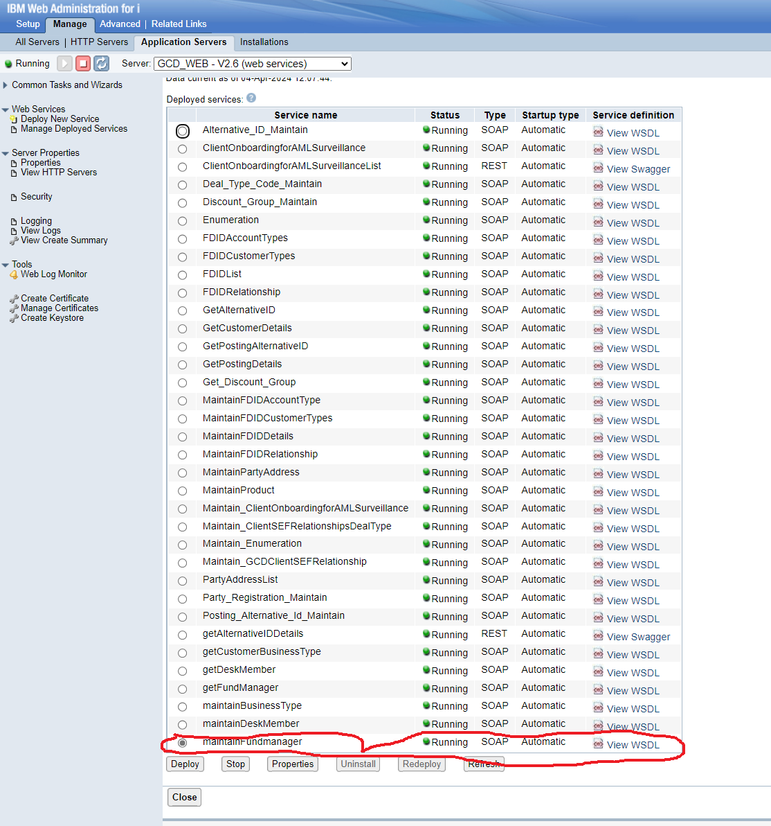

- Go to soap UI.
Create new SOAP project. To paste in the WSDL copy the WSDL from the web administrator.

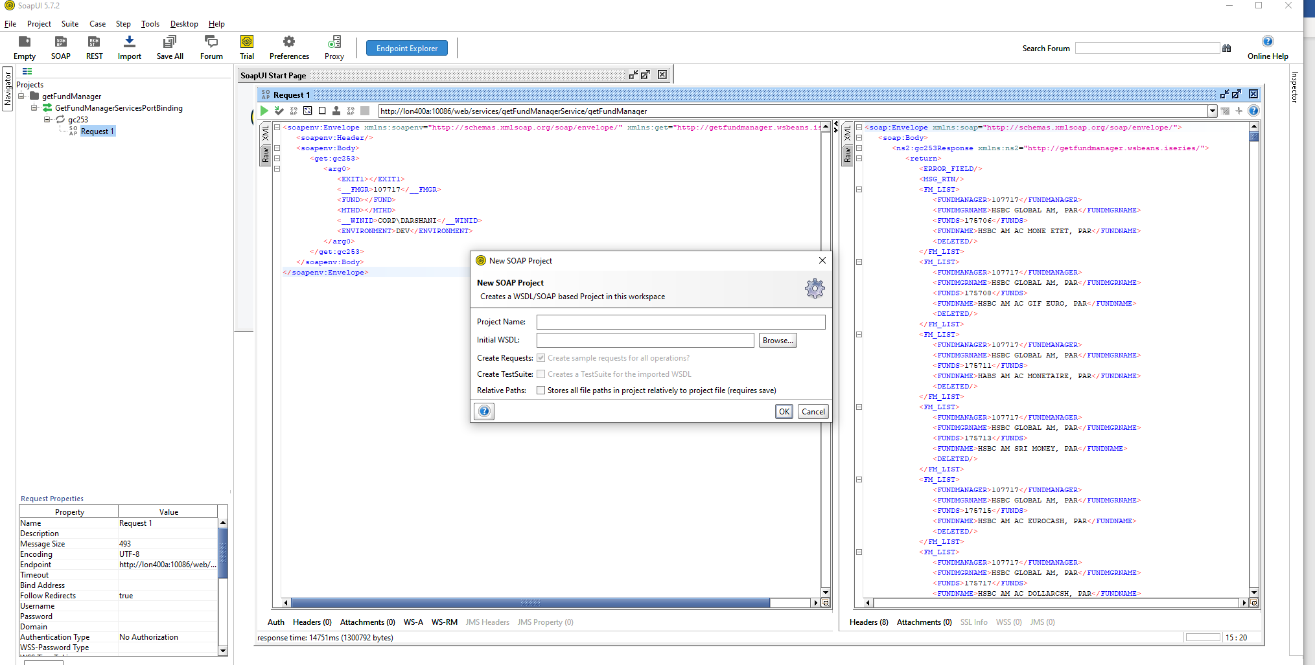

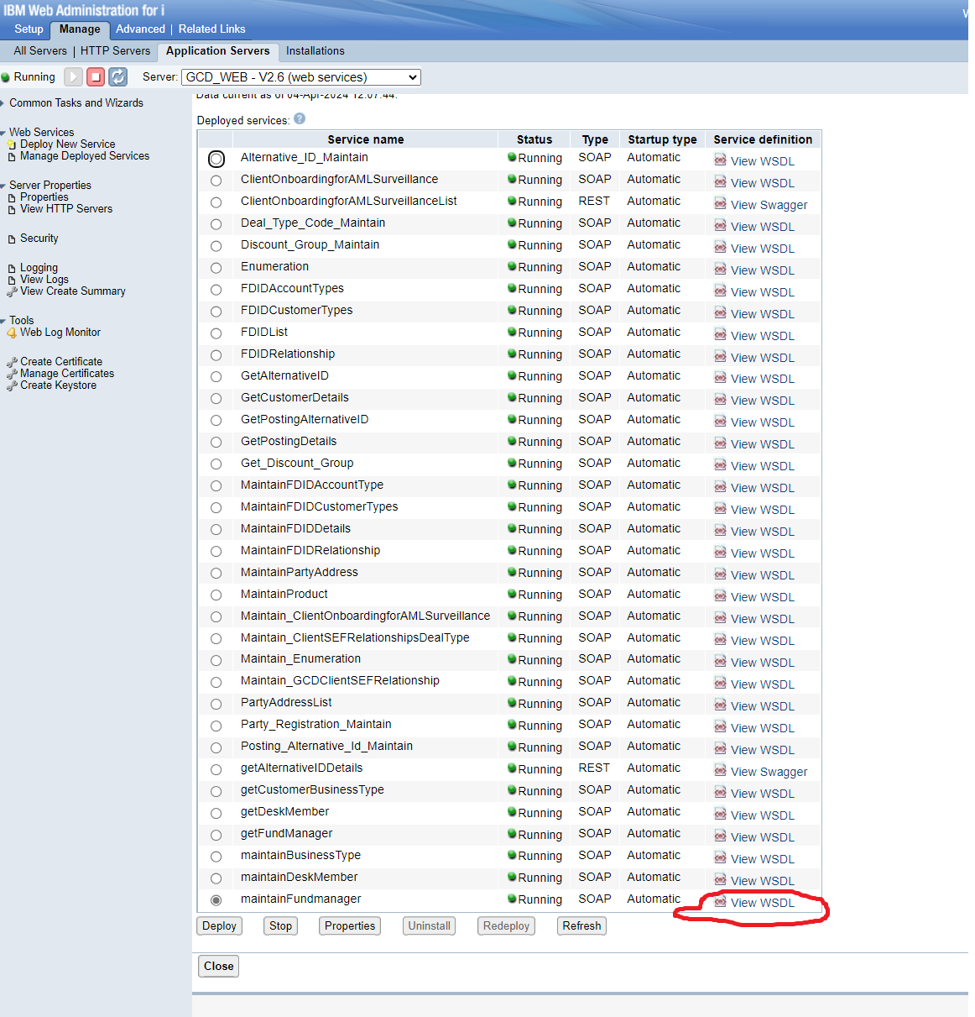

- Copy the URL of WSDL.
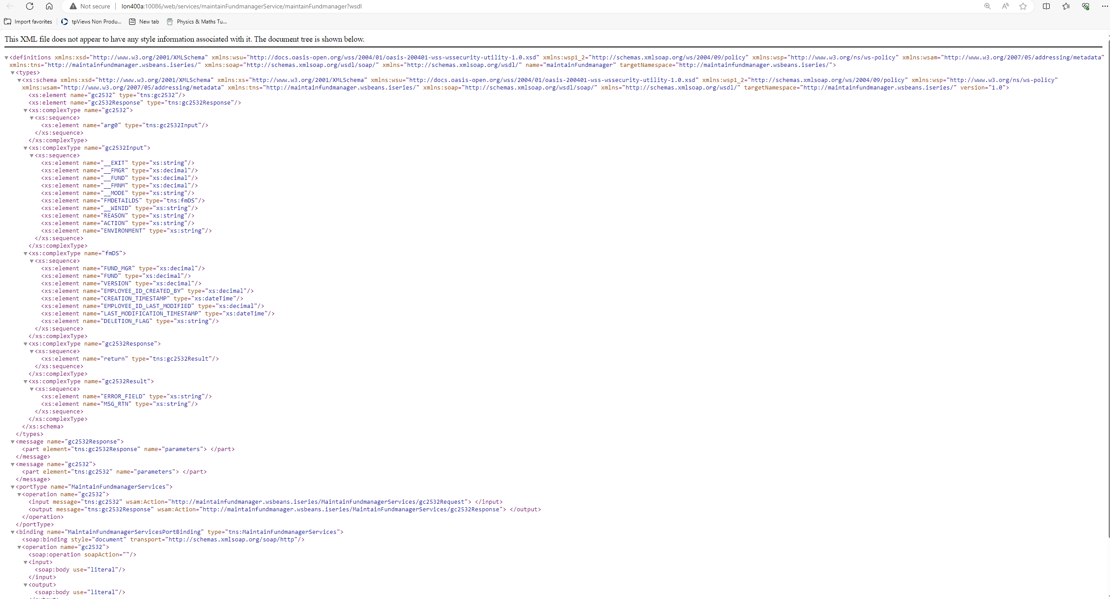

- Paste it in the SOAP UI project WSDL section. Then give a proper name for the project.
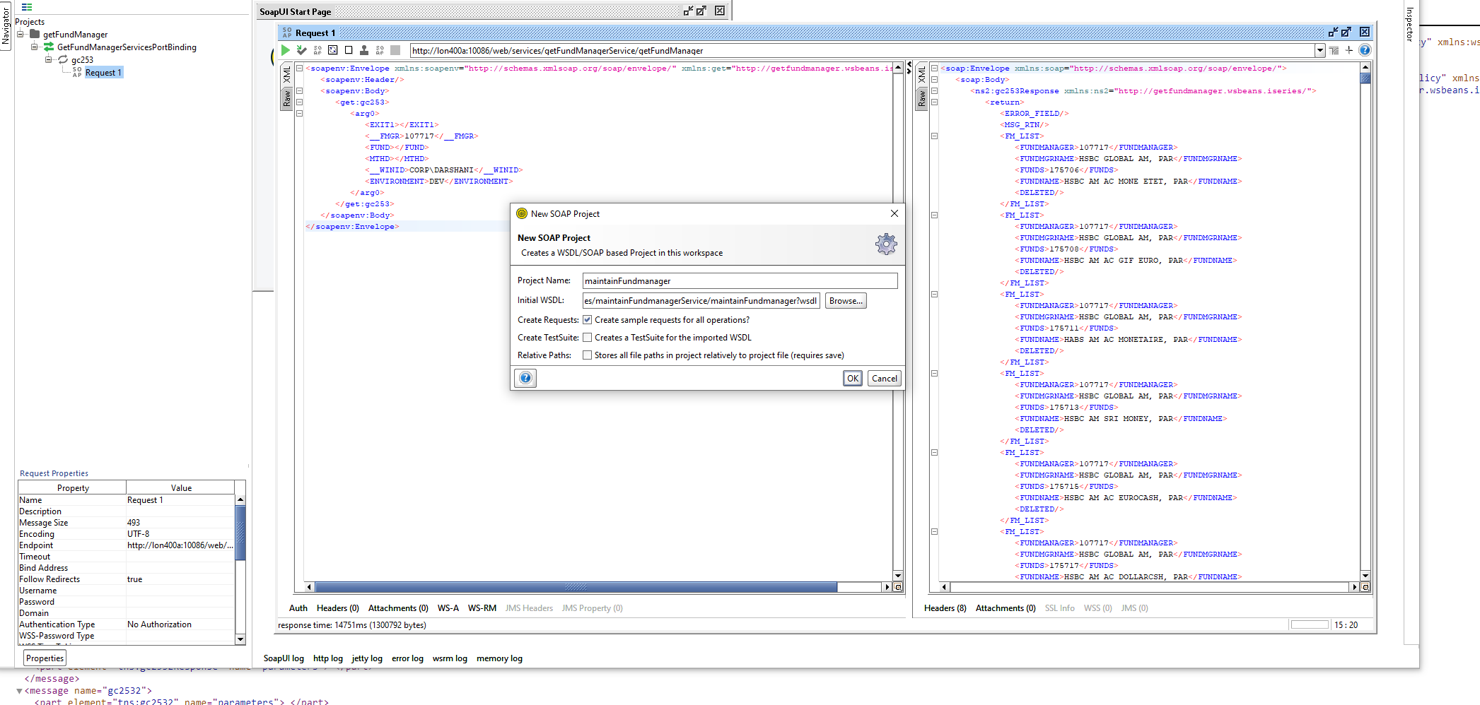

- Give some values and test the web service.
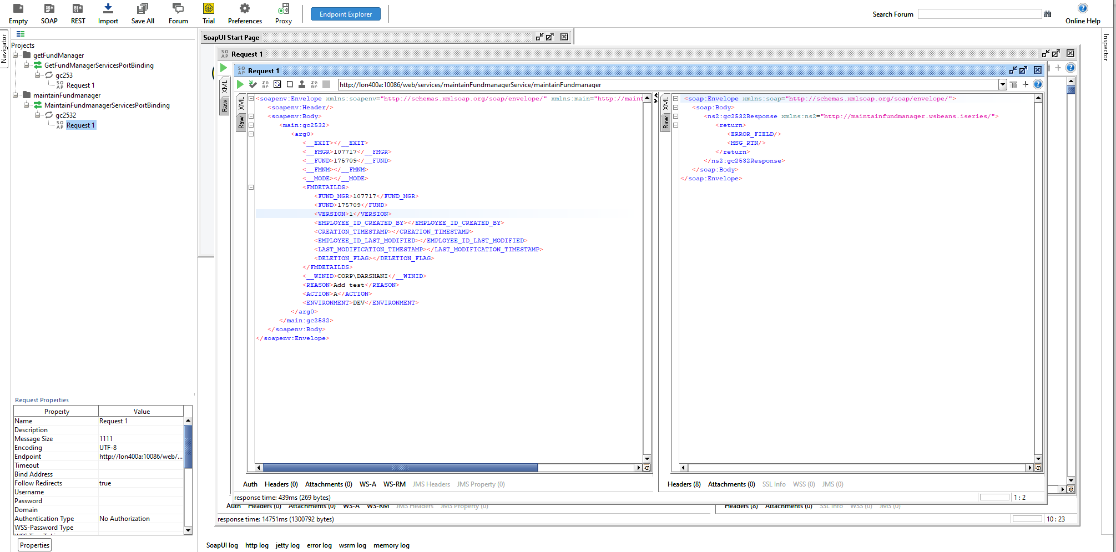

- How to debug
- WRKACTJOB and find the exact web service job. Copy the job number.
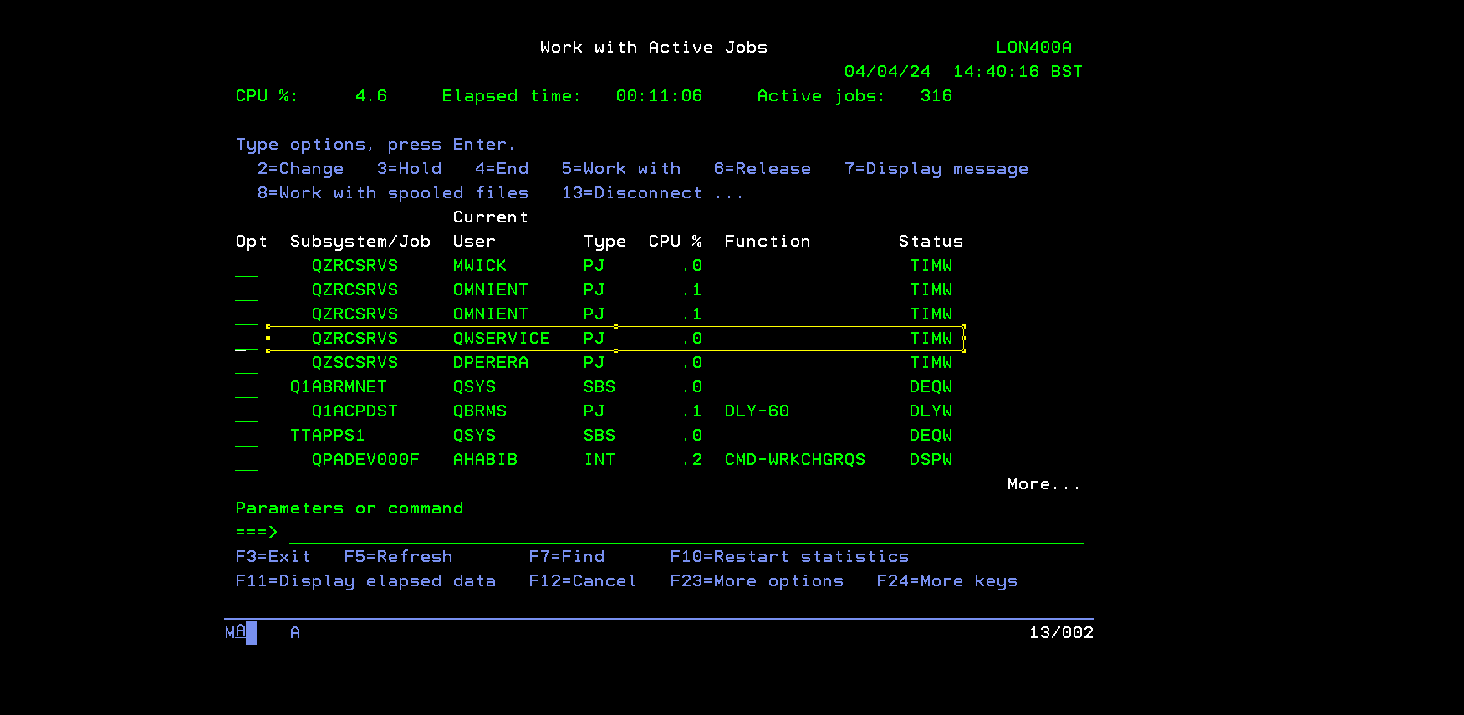

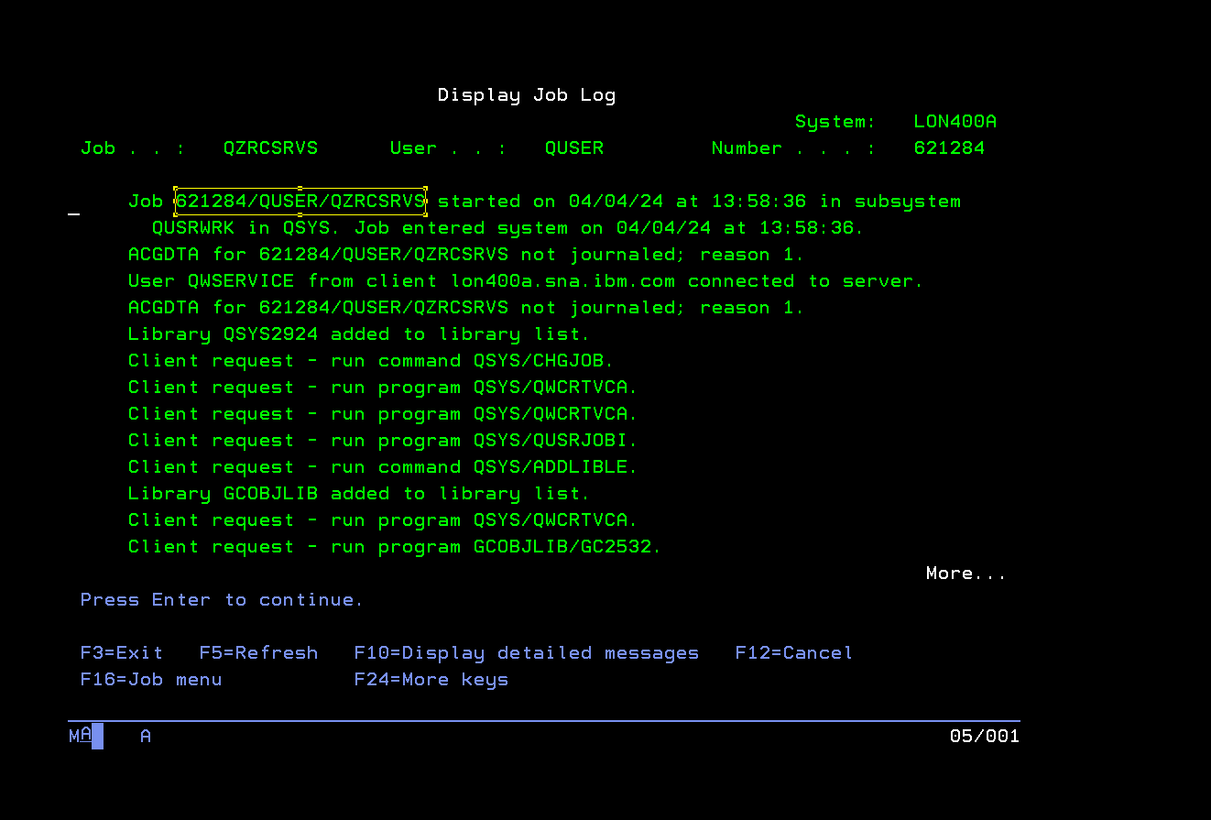
- strsrvjob (621284/QUSER/QZRCSRVS)
- strdbg
- 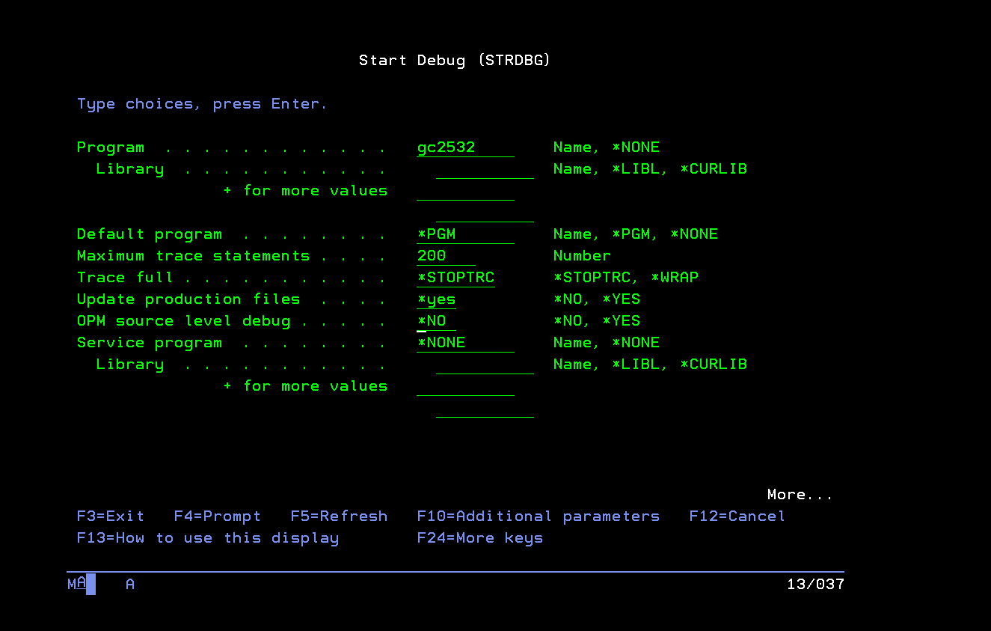
- f run_ws and put break point there.
- Run the web service from SOAP UI.
- This will automatically come to the break point in AS400.

Legal name subs
<__EXIT></__EXIT>
<__TCSTN>103325</__TCSTN>
<__CCSTN>104286</__CCSTN>
<__DLTYP>IRS</__DLTYP>
<__CURR1>JPY</__CURR1>
<__CURR2>JPY</__CURR2>
<__VER></__VER>
<__MTHD></__MTHD>
<__WINID>CORP\DARSHANI</__WINID>
<!--1 or more repetitions:-->
<LNAME_LIST>
<TRACUSNO>103325</TRACUSNO>
<COUNTCUSNO>104286</COUNTCUSNO>
<DEALTYPE>IRS</DEALTYPE>
<CURRENCY1>JPY</CURRENCY1>
<CURRENCY2>JPY</CURRENCY2>
<CLEARERID></CLEARERID>
<SUBCUSNO>177416</SUBCUSNO>
</LNAME_LIST>
<ENVIRONMENT>DEV</ENVIRONMENT>

To see the UAT deployment error
Put 10 in front of the CR.
Then copy the release note like 168208/DMS/O#LIV04682
wrkjob (168208/DMS/O#LIV04682)
Then see spool files to see the error.

